**A**

**PROJECT REPORT**

**ON**

**E-VOTING SYSTEM USING BLOCKCHAIN**

***Submitted by***

**Aayush Jain (0206IS211002)**

**For Partial Fulfilment of the Requirements for Bachelor of Technology in**

**Computer Science – IoT, Cybersecurity including Blockchain Technology**

**November, 2023**

**Computer Science- IoT Department**

**Gyan Ganga Institute Of Technology And Sciences**

**Jabalpur, Madhya Pradesh**

**INDIA**

**ABSTRACT**

Democratic voting is a crucial and serious event in any place, the current election scheme in any place, be it a school college, or even a country is done through ballot papers or using EVM. This process has many disadvantages such as transparency, low voter turnout, vote tampering, lack of trust in electoral authorities, delay in results, and above all security issues. So the growing digital technology has helped many people's lives nowadays. The concept of electronic voting is introduced to combat the disadvantages of the traditional voting system. Electronic voting is essentially an electronic means of casting and counting votes. It is an efficient and cost-effective way of conducting a voting procedure that is data-rich and real-time and requires high security. Nowadays, concerns about the security of networks and the privacy of communications for electronic voting have increased. Thus, the provision of electronic voting is very urgent and is becoming a popular topic in communication and networking. One way to solve security problems is blockchain. The paper proposes a new blockchain-based electronic voting system that addresses some of the limitations in existing systems and evaluates some of the popular blockchain frameworks to create a blockchain-based electronic voting system. Because the blockchain stores its data in a decentralized manner, the implementation result shows that it is a practical and secure electronic voting system that solves the problem of vote forgery in electronic voting. The blockchain-based electronic voting system can be directly applied to various network applications.

**LIST OF FIGURES**

Figure 1 Blockchain Core Component 4

Figure 2 Class Diagram 11

Figure 3 Use Case Diagram 13

Figure 4 Sequence Diagram 15

Figure 5 DFD Level 0 17

Figure 6 DFD level 1 17

Figure 7 Event Trace Diagram 19

Figure 8 State Diagram 21

Figure 9 Overview Of System 23

Figure 10 Hash Table 25

Figure 11 Simplified Bitcoin Blockchain 26

Figure 12 Architecture of E-Voting 27

Figure 13 Smart Contract Working 30

Figure 14 Blockchain Transaction Flow 33

Figure 15 Find Face 34

Figure 16 Extract Facial Feature 35

Figure 17 Identify Faces 35

Figure 18 Project Timeline Chart 37

Figure 19 Admin Login 40

Figure 20 Admin Dashboard 41

Figure 21 View Users 41

Figure 22 Add User 42

Figure 23 Add Candidate 42

Figure 24 Add Election 43

Figure 25 Edit Phase 43

Figure 26 Elections 44

Figure 27 Candidates of Elections 44

Figure 28 User Login Page 45

Figure 29 Transcation Details 46

Figure 30 Result of Elections 47

Figure 31 Candidate Result 47

**LIST OF TABLES**

Table 1 Class Diagram Symbol Table 10

Table 2 Use Case Diagram Symbol Table 12

Table 3 Sequence Diagram Symbol Table 14

Table 4 Data Flow Diagram Symbol Table 16

Table 5 Event Trace Diagram Symbol Table 18

Table 6 State Diagram Symbol Table 20

**TABLE OF CONTENTS**

Chapter 1: Introduction 1

1.1 Aim of the project 1

1.2 Project Scope 1

1.3 Project Objectives 1

1.4 Project Modules 2

1.5 Project Basic Requirements 2

1.5.1 Hardware Requirements 2

1.5.2 Software Requirements 2

1.5.3 Software requirements for our clients 2

Chapter 2: Literature review 3

2.1 Introduction 3

Chapter 3: Analysis, Design Methodology and Implementation Strategy 8

3.1 Project Feasibility study 8

3.1.1 Economical Feasibility 8

3.1.2 Technical Feasibility 8

3.1.3 Operational Feasibility 8

3.2 Detailed Module Description 9

3.2.1 Login 9

3.2.2 Voting 9

3.2.3 Voting Creation 9

3.2.4 Voting Result 9

3.2.5 User Identification 9

3.3 Project SRS 10

3.3.1 Class Diagram 10

3.3.2 Use-case Diagram 11

3.3.3 Sequence Diagram 13

3.3.4 Data Flow Diagram 15

3.3.5 Event Trace Diagram 18

3.3.6 State Diagram 19

3.4 Methodology 21

3.4.1 Registration Stage 21

3.4.2 Login 22

3.4.3 Blockchain Technology 22

3.4.4 Ethereum 22

3.4.5 Database 22

3.4.6 Admin 22

3.4.7 Results Phase 23

3.4.8 Meta Mask 23

3.4.9 Truffle 23

3.5 Voting Process 24

3.6 Blockchain 25

3.6.1 Introduction 25

3.6.2 Solidity 29

3.6.3 Smart Contract 30

3.6.4 Ethereum 31

3.6.6 Truffle 32

3.6.7 Ganache 33

3.7 Face Recognition 34

3.7.1 Features 34

3.7.2 Command-Line Interface 36

3.8 Timeline Chart 37

Chapter 4: Implementation and Testing 38

4.1 Software and Tools 38

4.1.1 Hardware Requirements 38

4.1.2 Software Requirements 38

4.1.3 Software requirements for our clients 39

4.2 User Interface and Snapshots 40

4.2.1 Admin Login 40

4.2.2 Admin Dashboard 41

4.2.3 View Users 41

4.2.4 Add User 42

4.2.5 Add Candidate 42

4.2.6 Add Election 43

4.2.7 Edit Phase 43

4.2.8 View Elections 44

4.2.9 Candidate of Election 44

4.2.10 Login User 45

4.2.11 Metamask Transaction Details 46

4.2.12 Result of Elections 47

4.2.13 Result of Candidates 47

Chapter 5: Conclusion and Future work 48

5.1 Conclusion 48

5.2 Future work 48

# **Chapter 1: Introduction**

## 1.1 Aim of the project

Online Voting system is a web-based voting system that will helps to manage your elections easily and more securely. This voting system can be used for casting votes during the elections held in colleges, etc.

It uses face recognition technique to authenticate the user so problems for dummy entries will also be solved. So, thus this system gives the guarantee that no cheating can be done and the voting will be conducted easily where people don’t have to go outside in order to cast their votes.

## 1.2 Project Scope

Transparent transaction using Blockchain technology increases the security of the transaction of crypto that races towards the cybersecurity.

All the data is secure and verified. The encryption is done through cryptography to eliminate vulnerabilities such as unauthorized data tampering and this will increase the crypto payments.

## 1.3 Project Objectives

* The main objective of the electronic voting technology intends to speed of the counting of ballots, reduce the cost of paying staff to count votes manually and can provide improved accessibility for disabled voters.
* This can be achieved by designing and developing a software platform for voter registration, election voting, real-time election results collation and monitoring and mostly for remote voters access to elections.
* Study and implement a security method to be used to ensure that votes being cast in the system will not be compromised and no outside attack would be faced which will be ensured by blockchain technology.

## 1.4 Project Modules

1. Login Module
2. Voting Module
3. Voting Creation Module
4. Voting Result Module
5. User Identification Module

## 1.5 Project Basic Requirements

### 1.5.1 Hardware Requirements

* + Any device containing camera with high procesing power.

### 1.5.2 Software Requirements

* Front-End: React-js
* Back-End: Node-js, Express-js, Solidity
* Blockchain: MetaMask, Ganache
* Others: Domain name, Hosting, sever and cloud storage

### 1.5.3 Software requirements for our clients

* Windows 7 or higher OS
* Google chrome or any other safe browser
* Good Internet Speed
* Blockchain ID with sufficient Etherium

# **Chapter 2: Literature review**

## 2.1 Introduction

Blockchain technology has several uses in various industries, such as banking and finance, IoT and media, energy, health, logistics, and many more. In addition, new fields and ways of use are continually being investigated. The authors of comprehensively evaluate several articles on Blockchain technology in information systems and give a comprehensive list of applications organized by Blockchain technology problems. This section provides a fundamental analysis of previous research that looked at scalable Blockchain technology for electronic voting. This research used digital libraries such as IEEE Xplore Digital Library, Scopus, ScienceDirect, SpringerLink, and ACM Digital Library to identify and review the existing literature to conduct a methodical study of such efforts. It allowed us to perform a rigorous study analysis of the efforts made.These are broad studies of Blockchain technology, and they mention scalability as a significant challenge for Blockchain. These examinations do not specifically investigate or address the scalability of Blockchain technology, and as a result, they have been excluded from the scope of the present study.

* **Core components of blockchain architecture**

1. **Node** — user or computer within the blockchain
2. **Transaction** — smallest building block of a blockchain system
3. **Block** — a data structure used for keeping a set of transactions which is distributed to all nodes in the network
4. **Chain** — a sequence of blocks in a specific order
5. **Miners** — specific nodes which perform the block verification process
6. **Consensus**— a set of rules and arrangements to carry out blockchain operations

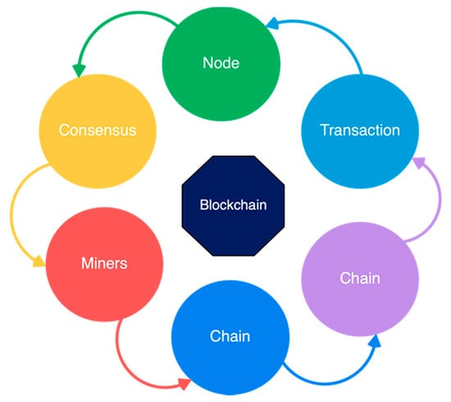

Figure Blockchain Core Component

Currently, research is being carried out on using Blockchain technology in online voting systems. The authors of describe and compare numerous Blockchain-based electronic voting systems in their summary on voting. The deployment of Blockchain-based electronic voting systems presents both threats and potential. Another significant survey was performed in, whose authors researched several Blockchain-based electronic voting systems to see how they adhere to existing international standards and conventions. To conclude, specific commercial Blockchain-based electronic voting systems are given and discussed in in addition to an open electronic voting platform.

The authors of investigated electronic voting obstacles and the present state of the Blockchain-based e-voting systems. According to , electronic voting may be unavoidable when comparing conventional voting with distant voting through the Internet. Finally, the authors of present an overview of the current voting systems by describing several voting techniques, their benefits and drawbacks, and technical breakthroughs in the sector.

Numerous articles have been written on merging Blockchain technology with electronic voting systems. The results show how each method has distinct aims and is executed differently in these articles. These publications cover a variety of techniques to accomplish various objectives using a variety of ways. That is why we are performing an SLR on scalable Blockchain-based electronic voting to obtain a handle on what is new in the industry.

In conclusion, these studies lack both a systematic strategy for conducting the review and sufficient depth in current initiatives to address the scalability of Blockchain for electronic voting. Consequently, there are gaps in the coverage of several aspects of Blockchain scalability and the survey’s depth and breadth. Furthermore, due to the ever-increasing length of the Bitcoin chain and recent advancements such as Segregated Witness (SegWit), the scalability of Blockchain has recently garnered significant interest. Consequently, a current and extensive effort is necessary to systematically assess the scalability of Blockchain technology for electronic voting based on its present level of development. This evaluation aims to identify the work that has already been carried out, the existing limitations, and the potential avenues for future research.

The paper  is based on using a technique called “systematic mapping”. It is organized around five research questions whose answers, according to the authors, cover the entire scope of their review: (1) What are the current e-voting system gaps ? (2) Can the blockchain concept improve e-voting systems ? (3) What are the research topics and proposed solutions that have been published in blockchain-based e-voting ? (4) Which blockchain platforms/consensus models are used? (5) What are the future research directions for the blockchain-based e-voting system? They have answered all these questions and more specifically question (3), which focuses on comparing between e-voting applications that are based on blockchain technology. They classified these applications into 5 categories, where each category represents the main purpose of the application or its main feature. This classification is not enough and it is not based on an obvious comparison between the applications. In our paper in hand, we extracted several properties shared by most blockchain-based e-voting applications, and then we defined a subset of comparison criteria by grouping them (the extracted properties) into 4 themes and hence 4 tables.

Primarily based on deep convolutional network techniques, Zhang adopted 3 ranges of deep convolutional networks that may predict the coarse-to-exceptional position of face and landmarks superbly. A current look at has proven that during this discipline, deep getting to know methods can have vast effects. The writer has advised CNNs for eye detection consisting of trio tiers: idea network (p-net), refinement community (r-net), and output network (o-net). Experimental consequences unearth these strategies to exceed trendy techniques over multiple disturbing assessments whilst keeping efficiency in actual-time.

Lai et al. suggested a decentralized anonymous transparent electronic voting system (DATE) requiring a minimal degree of confidence between participants. They think that for large-scale electronic elections, the current DATE voting method is appropriate. Unfortunately, their proposed system is not strong enough to secure from DoS attacks because there was no third-party authority on the scheme responsible for auditing the vote after the election process. This system is suitable only for small scales because of the limitation of the platform. Although using Ring Signature keeps the privacy of individual voters, it is hard to manage and coordinate several signer entities. They also use PoW consensus, which has significant drawbacks such as energy consumption: the “supercomputers” of miners monitor a million computations a second, which is happening worldwide. Because this arrangement requires high computational power, it is expensive and energy-consuming.

Shahzad et al. proposed the BSJC proof of completeness as a reliable electronic voting method. They used a process model to describe the whole system’s structure. On a smaller scale, it also attempted to address anonymity, privacy, and security problems in the election. However, many additional problems have been highlighted. The proof of labor, for example, is a mathematically vast and challenging job that requires a tremendous amount of energy to complete. Another problem is the participation of a third party since there is a significant risk of data tampering, leakage, and unfair tabulated results, all of which may impact end-to-end verification. On a large scale, generating and sealing the block may cause the polling process to be delayed .

Gao et al. has suggested a blockchain-based anti-quantum electronic voting protocol with an audit function. They have also made modifications to the code-based Niederreiter algorithm to make it more resistant to quantum assaults. The Key Generation Center (KGC) is a certificateless cryptosystem that serves as a regulator. It not only recognizes the voter’s anonymity but also facilitates the audit’s functioning. However, an examination of their system reveals that, even if the number of voters is modest, the security and efficiency benefits are substantial for a small-scale election. If the number is high, some of the efficiency is reduced to provide better security.

Yi presented the blockchain-based electronic voting Scheme (BES) that offered methods for improving electronic voting security in the peer-to-peer network using blockchain technology. A BES is based on the distributed ledger (DLT) may be employed to avoid vote falsification. The system was tested and designed on Linux systems in a P2P network. In this technique, counter-measurement assaults constitute a significant issue. This method necessitates the involvement of responsible third parties and is not well suited to centralized usage in a system with many agents. A distributed process, i.e., the utilization of secure multipart computers, may address the problem. However, in this situation, computing expenses are more significant and maybe prohibitive if the calculation function is complex and there are too many participants.

Khan, K.M. has proposed block-based e-voting architecture (BEA) that conducted strict experimentation with permissioned and permissionless blockchain architectures through different scenarios involving voting population, block size, block generation rate, and block transaction speed. Their experiments also uncovered fascinating findings of how these parameters influence the overall scalability and reliability of the electronic voting model, including interchanges between different parameters and protection and performance measures inside the organization alone. In their scheme, the electoral process requires the generation of voter addresses and candidate addresses. These addresses are then used to cast votes from voters to candidates. The mining group updates the ledger of the main blockchain to keep track of votes cast and the status of the vote. The voting status remains unconfirmed until a miner updates the main ledger. The vote is then cast using the voting machine at the polling station.

However, in this model, there are some flaws found. There is no regulatory authority to restrict invalid voters from casting a vote, and it is not secure from quantum attach. Their model is not accurate and did not care about voter’s integrity. Moreover, their scheme using Distributed consensus in which testimonies (data and facts) can be organized into cartels because fewer people keep the network active, a “51%” attack becomes easier to organize. This attack is potentially more concentrated and did not discuss scalability and delays in electronic voting, which are the main concerns about the blockchain voting system. They have used the Multichain framework, a private blockchain derived from Bitcoin, which is unsuitable for the nationwide voting process. As the authors mentioned, their system is efficient for small and medium-sized voting environments only.

# **Chapter 3: Analysis, Design Methodology and Implementation Strategy**

## 3.1 Project Feasibility study

Feasibility Study is the Measure of how beneficial or practical the development of the System will be to the Organization. It is a Preliminary survey for the Systems Investigation. It aims to provide information to facilitate a later in-depth investigation. The Report is Produced at the end of the feasibility study contains suggestions and reasoned arguments to help management decide whether to commit further resources to the proposed project.

### 3.1.1 Economical Feasibility

In the economic feasibility, the development cost in creating the system is evaluated against the ultimate benefit derived from the new systems. Financial benefits must equal or exceed the costs. The system will be Economically Feasible if it Successfully Developed with at least 95% Accuracy.

### 3.1.2 Technical Feasibility

This is the study of function, performance and constraints that may affect the ability to achieve an acceptable system. For this feasibility study, we studied complete functionality to be provided in the system, as described in the System Requirement Specification (SRS), and checked if everything was possible using different type of frontend and backend platform.

### 3.1.3 Operational Feasibility

No doubt the proposed system is fully GUI based that is very user friendly and all inputs to be taken all self-explanatory even to a layman. Besides, a proper training has been conducted to let know the essence of the system to the users so that they feel comfortable with new system. As far our study is concerned the clients are comfort table and happy as the system has cut down their loads and doing.

## 3.2 **Detailed Module Description**

### 3.2.1 Login

This modules describes about login functionality in which there are two types of login are there 1) User Login 2) Admin Login**.**

### 3.2.2 Voting

In this module user can cast their votes. This module will describe a whole page where there will be list of candidates were noted with their symbols .

### 3.2.3 Voting Creation

In admin can create whole voting environment (i.e. arrange voting facility, specifies time of voting, add candidates that have stand, and records the entry that particular person has voted, etc ).

### 3.2.4 Voting Result

This module is the main module of our system as it gives the result of the voting. As we have used blockchain technology our votes will not be not be altered and thus purity maintains and the proper candidate will be won.

### 3.2.5 User Identification

This module system will authenticate user that particular user is valid or not. This authentication will be done by face recognition system where user will have to scan their face to access the voting portal in order to make voting system crystal clear because due to this no other person can cast vote in place of a particular user.

## 3.3 Project SRS

### 3.3.1 Class Diagram

A class is a description of a set of objects that share the same attributes, operations, relationships, and semantics.

* **Symbols**

|  |  |
| --- | --- |
|  | Classname : The name of the class is the only required tag in the graphical representation of a class. It always appears in the top-most compartment.  Attributes : An attribute is a named property of a class that describes the object being modeled. In the class diagram, attributes appear in the second compartment just below the name-compartment.  Attributes can be : + public  # protected  - private  / derived  Operation : Operations describe the class behavior and appear in the third compartment. |

Table Class Diagram Symbol Table

* **Diagram**

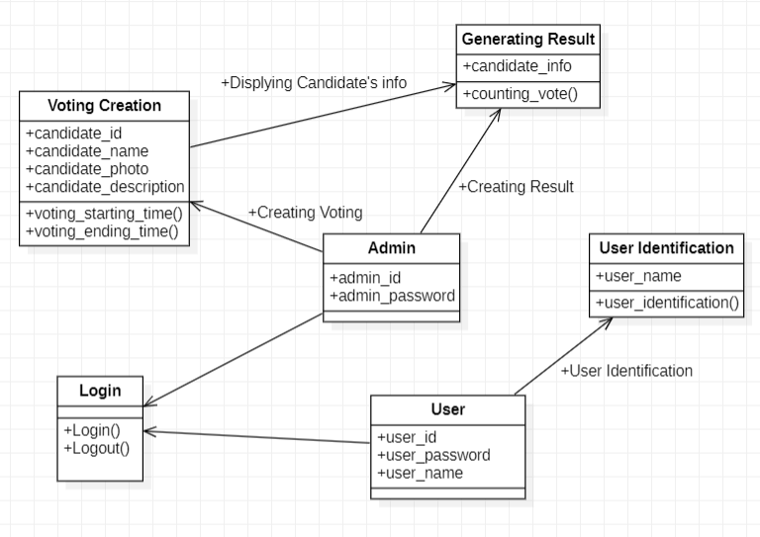

Figure Class Diagram

### 3.3.2 Use-case Diagram

Use case diagrams are a common way to communicate the major functions of a software system. A use case diagram at its simplest is a representation of a user's interaction with the system that shows the relationship between the user and the different use cases in which the user is involved. A use case diagram can identify the different types of users of a system and the different use cases and will often be accompanied by other types of diagrams as well.

Use cases are nothing but the system functionalities written in an organized manner. Now another thing which is relevant to the use cases are the actors. Actors can be defined as something that interacts with the system.

So in brief, the purposes of use case diagrams can be as follows:

1. Used to gather requirements of a system.
2. Used to get an outside view of a system.
3. Identify external and internal factors influencing the system.
4. Show the interacting among the requirements are actors.

* **Symbols**

|  |  |
| --- | --- |
|  | An actor is rendered as a stick figure in a use case diagram. Each actor participates in one or more use cases |
| Use Case | People, processes, or other systems that interact with information systems that will be created outside the information system that will be created themselves. |

Table Use Case Diagram Symbol Table

* **Diagram**

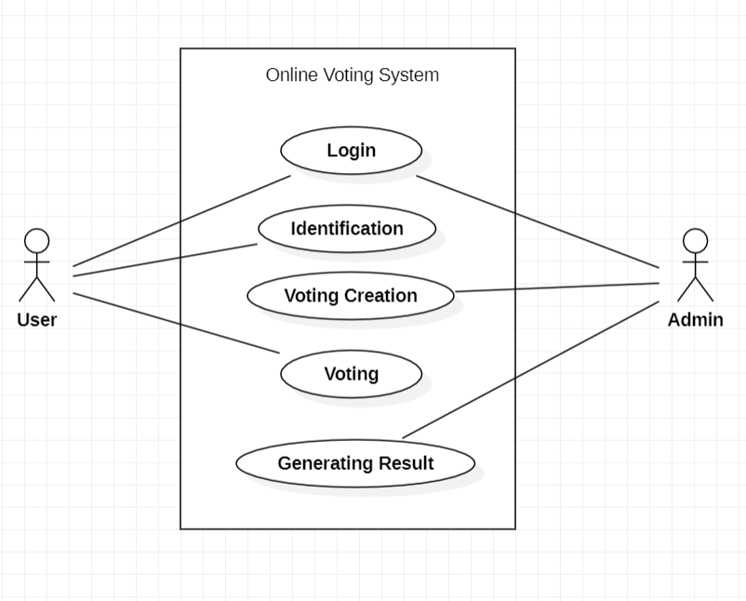

Figure Use Case Diagram

### 3.3.3 Sequence Diagram

Sequence diagram represents the behavioural aspects of a system. Sequence diagram shows the interactions between the objects by means of passing messages from one object to another with respect to time in a system.

Sequence diagram contains the objects of a system and their life-line bar and the messages passing between them. Objects appear at the top portion of sequence diagram. Object is shown in a rectangle box. Name of object precedes a colon ‘:’ and the class name, from which the object is instantiated. The whole string is underlined and appears in a rectangle box. A down-ward vertical line from object-box is shown as the life-line of the object. A rectangle bar on life-line indicates that it is active at that point of time. Messages are shown as an arrow from the life-line of sender object to the life-line of receiver object and labelled with the message name.

* **Symbols**

|  |  |
| --- | --- |
|  | An Lifeline in a sequence diagram is rendered as a box with a dashed line descending from it. The line is called the object lifeline, and it represents the existence of an object over a period of time. |
|  | Messages are rendered as horizontal arrows being passed from object to object as time advances down the object lifelines. Conditions indicate when a message gets passed |

Table Sequence Diagram Symbol Table

* **Diagram**

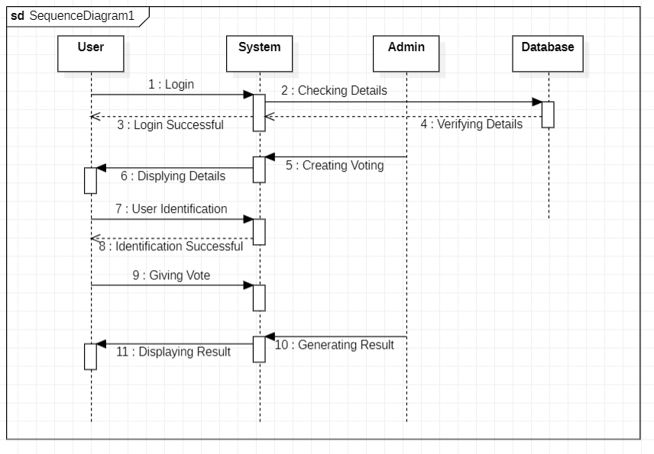

Figure Sequence Diagram

### 3.3.4 Data Flow Diagram

DFD provides the functional overview of a system. The graphical representation easily overcomes any gap between ’user and system analyst’ and ‘analyst and system designer’ in understanding a system. Starting from an overview of the system it explores detailed design of a system through a hierarchy.

DFD shows the external entities from which data flows into the process and also the other flows of data within a system. It also includes the transformations of data flow by the process and the data stores to read or write a data.

* **Symbols**

|  |  |
| --- | --- |
|  | Process |
|  | Data Flow |
|  | Data Store |
|  | Source / Sink |

Table Data Flow Diagram Symbol Table

* **Diagram**
* **DFD level 0 :**

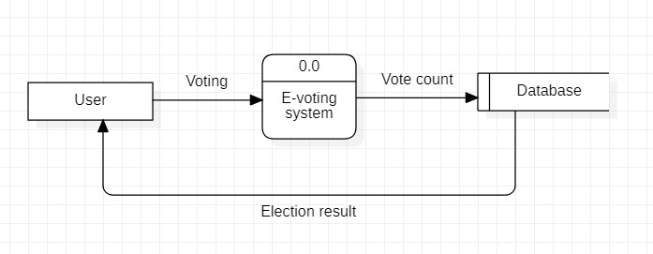

Figure DFD Level 0

* **DFD level 1 :**

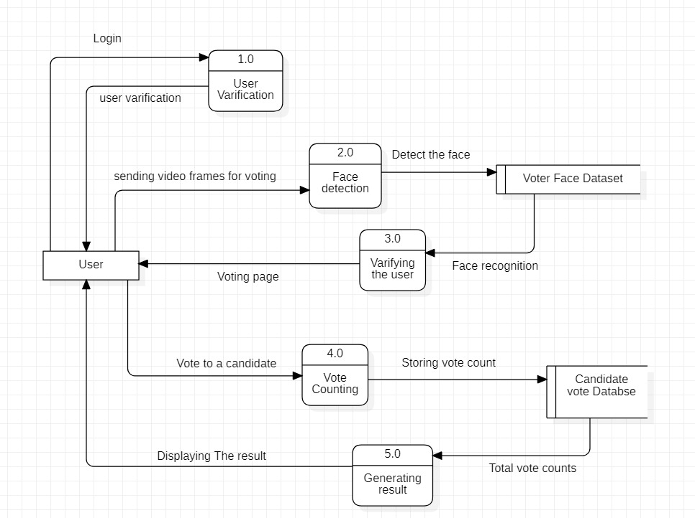

Figure DFD level 1

### 3.3.5 Event Trace Diagram

A event Trace diagram simply depicts interaction between objects in a sequential order. i.e. the order in which these interactions take place. We can also use the terms event diagrams or event scenarios to refer to a sequence diagram.

* **Symbols**

|  |  |
| --- | --- |
|  | Start State |
|  | Final State |
|  | Simple State |

Table Event Trace Diagram Symbol Table

* **Diagram**

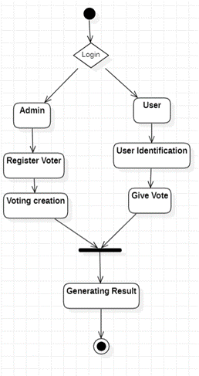

Figure Event Trace Diagram

### 3.3.6 State Diagram

A state diagram is a type of diagrams used in computer Science and related fields to describe the behavior of systems. State diagrams require that the system described is composed of a finite number of states; sometimes, this is indeed the case, while at other times this is a reasonable abstraction. Many forms of state diagrams exist, which differ slightly and have different semantics.

* **Symbols**

|  |  |
| --- | --- |
|  | Start State |
|  | Final State |
|  | Simple State |
|  | Concurrent Composite State |
|  | Sequential Composite State |

Table State Diagram Symbol Table

* **Diagram**

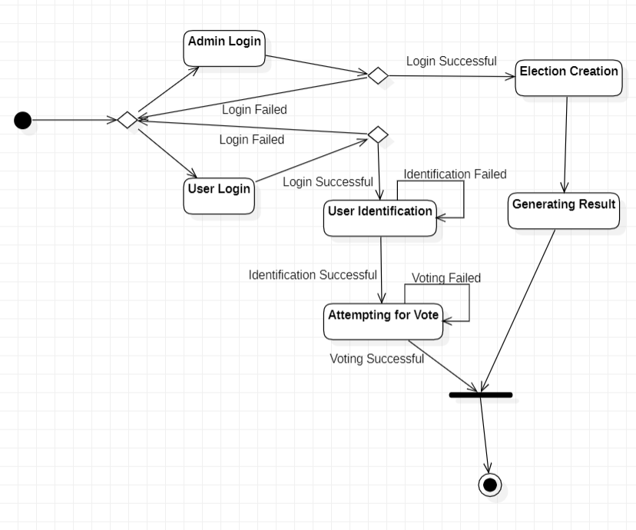

Figure State Diagram

## 3.4 Methodology

In this section, we will show the design and functional phase of our application. The user accesses the web application where the platform is hosted and registers as well as votes securely and transparently. The methodology is given below.

### **3.4.1 Registration Stage**

In this stage, the voter has to register with his unique aadhar number, email address, name, and phone number. They also need to add their clear photo here as this system uses facial recognition technology to log in.

### 3.4.2 Login

After registration, the voter tries to log in and cast his vote. At this stage, the voter first logs in using a password. After successful login, the voter must authenticate to vote. For real-time authentication, facial recognition technology is used to increase the level of security.

### 3.4.3 Blockchain Technology

This technology is mainly used for its security features. Blockchain provides a secure and transparent environment. Blockchain encrypts the voter’s message (Casted vote) using an asymmetric encryption algorithm. The public key is provided by the Blockchain and the private key is with the host. The public key is used for authentication purposes using the ledger.

### 3.4.4 Ethereum

The Ethereum network provides a framework for creating and storing the blockchain. Each block is created and its details are stored in an encrypted ledger. These generated blocks are distributed among the nodes, providing the system with high fault tolerance. To cast a vote, a user must use Ethereum for their transactions. So Ganache is used for this. Ganache is a private Ethereum blockchain environment that allows you to emulate the Ethereum blockchain to interact with smart contracts on your private blockchain.

### 3.4.5 Database

All system data is stored in the MongoDB database. The data will be in the form of voter and candidate names, unique voter IDs, and voting details like time, time slot, region, etc.

### 3.4.6 Admin

Admin will control the entire environment. Verification of voters and candidates will be done by admin. Admin only arranges the voting schedule. All important notifications like results etc are also under admin control.

### 3.4.7 Results Phase

The processing and counting of votes take place in the results phase. The results are generated and displayed on the website. Users can verify their votes using their public key. This ensures the transparency of the voting system.

### 3.4.8 Meta Mask

Metamask allows blockchain users to manage their wallets. Using the browser extension, users can use the wallet and perform transactions through the browser. When a transaction is performed, a meta mask pops up and asks the user to confirm the transaction.

3.4.9 Truffle

Truffle offers an improved environment primarily based totally on the Ethereum blockchain. Truffle is capable of compiling the Ethereum contracts and migrating them. After migration contracts are deployed on ganache, any Ethereum takes a look at the net (e.g. Ropsten, Rinkeby, local network) or on an actual Ethereum network.

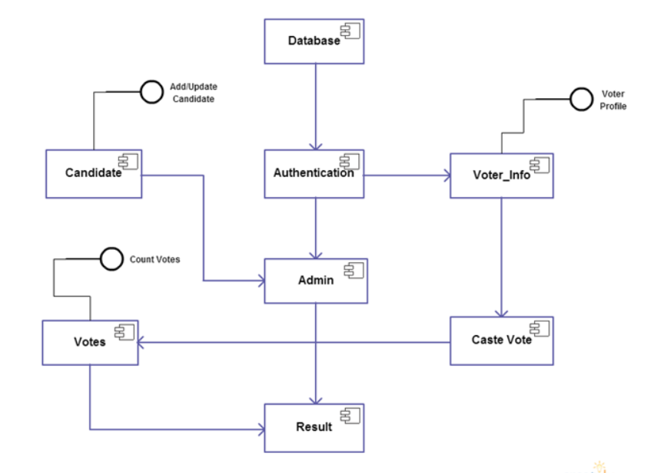

Figure Overview Of System

## 3.5 Voting Process

We now describe a typical user interaction with the proposed scheme based on our current system implementation. So basically the voter logs into the system by scanning their face. After scanning the face, the facial recognition system authenticates the voter. If a match is found, the voter is presented with a list of available candidates with the option to vote against them. Conversely, if the match is unsuccessful, any further access would be denied. This functionality is achieved by using an appropriate implementation of an authentication mechanism (in this case a facial recognition system) and predefined role-based access control. Furthermore, it is also assumed that the voter is assigned to his particular electoral district and this information is used to create a list of candidates for which the voter can vote. Assigning a voter to a constituency is considered an offline process and is therefore beyond the scope of this research.

After successfully casting votes, it is mined by multiple miners for verification, after which valid and verified votes are added to the public ledger. The security aspects of voting are based on blockchain technology using cryptographic hashes to secure end-to-end verification. For this purpose, a successfully cast vote is considered a transaction within the voting application's blockchain. Therefore, the casting vote is added as a new block (after successful mining) in the blockchain and is also recorded in the data tables at the end of the database. The system ensures ownership of voting systems for only one person and one vote. This is achieved by using a unique voter face that matches at the start of each voting attempt to prevent double voting. Once miners mine a vote, a transaction is generated that is unique to each vote. If the vote is found to be malicious, the miner is rejected.

After the validation process, a notification is immediately sent to the voter via message or email with the transaction ID defined above, through which the user can track their vote to the ledger. While this works as a voter notification, it does not allow any user to extract information about how a particular voter voted, thereby achieving voter privacy. It is important to note here that the cryptographic hash for the voter is the unique hash of the voter by which the voter is known in the blockchain. This feature makes it easier to achieve verifiability of the entire voting process. In addition, this id is hidden and no one can view it, not even the system operator or administrator can view this hash, thereby achieving the privacy of individual voters.

## 3.6 Blockchain

### 3.6.1 Introduction

Blockchain technology is shining sort of a star these days when its entry and wide-spread adoption of Bitcoin, the terribly initial cryptocurrency that involves people's minds. Blockchain technology originates from the fundamental subject style of the bitcoin cryptocurrency, wherever it absolutely was initial introduced to the net world and previously became a promising technology thanks to the high degree of transparency within the system, turning into a vigorous space of analysis and study for its varied applications. alternative fields.

Blockchain, simply put, may be a shared, changeless ledger that facilitates the method of recording transactions and following assets in a very business network. Associate in Nursing quality are often tangible (house, car, cash, land) or intangible (intellectual property, patents, copyrights, branding). during this era nearly we are able to track and trade something on a blockchain network, reducing prices and risk for everybody. Blockchain stores its knowledge in blocks. First, all the info to be keep within the blockchain is reborn into smaller components, that square measure allotted to totally different blocks within the suburbanized network. The ini-tial block in a very blockchain is understood as a "Genesis Block" or "Block 0". "Block Gene-sis" or "Block 0". The genesis block is sometimes hard-coded into software; is peculiar therein it doesn't contain a link to the previous block. The genesis block is sometimes hard-coded into the software; it's special therein it doesn't contain a regard to the previous block (the Genesis block).

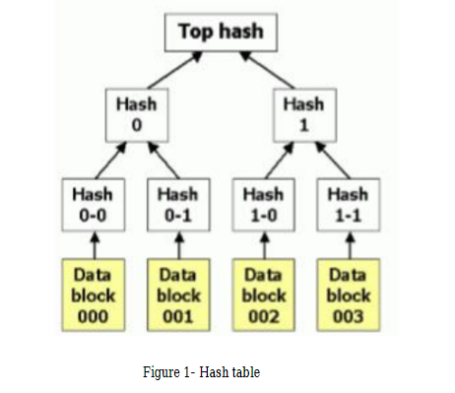

Figure Hash Table

Once the genesis block is initialized, "Block 1" is created and when completed is attached to the genesis block. Each block has a transaction data part, a copy of each of the transactions is hashed and then the hashes are matched and hash again, this continues until there is only one hash left; to known as the Merkle root (Figure 10). The block header is where the Merkle root is stored, which ensures that the transaction cannot be modified by third parties.

Blockchain is designed to be accessed through a peer-to-peer network, each node then communicates with other nodes to exchange blocks and transactions. A blockchain block consists of a block header, a hash value of the previous block header, and a Merkle root. So when we extract data from the blockchain, then all the smaller parts that are in the decentralized network are connected by accessing all the blocks through their hash values. If a person or a third party wants to change the data, they need to know the hash values ​​of all the tables, without them they can't take even a bit of information about our data. Because these data blocks are distributed in thousands and thousands of blocks, it takes a hacker more than millions of years to find the hash values ​​of all the blocks. Thanks to these features, it provides safety, reliability, and robustness.

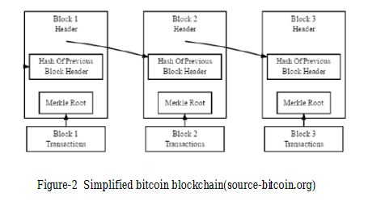

Figure Simplified Bitcoin Blockchain

Before 2004 there was a paper-primarily based totally vote casting device referred to as ballot paper device in India. So, to eliminate all the shortcomings of the traditional voting system, the blockchain fits as the best suitable solution for the e-voting platform. Electronic voting is extensively studied and many implementations are tested and even used for a while where we encountered some problems like user authentication, vote tempering, etc. Of course, there are many government websites like polls, networks to gain knowledge about new government schemes, questionnaires where common people raise their questions, etc. still we can't say the same for online elections because every vote matters here for a candidate so the system needs to be more secure, reliable and authentic. This is mainly because official elections are the basic elements of democracy and democratic governance which is the most preferred administrative methodology in the modern world. The electronic voting system will be a new change from the regular voting system, which is less complicated, and more open to the voters, and besides, security will come first. These tactics reduce the cost of many laws to some voters by creating more ways for them to cast a ballot. This gives it a chance to survive long queues at check stations and offers a better experience to those who are sick, serving in the military, people living abroad or gone abroad on holiday, etc. It has been found that many people did not vote due to laziness, so it can serve its purpose here in the electronic voting system. And all the things in today's world are digitized, then the electoral system falls behind, young people between the ages of 18 and 30 are special voters, and the web is a process to attract those citizens who seem to be the hardest to reach.

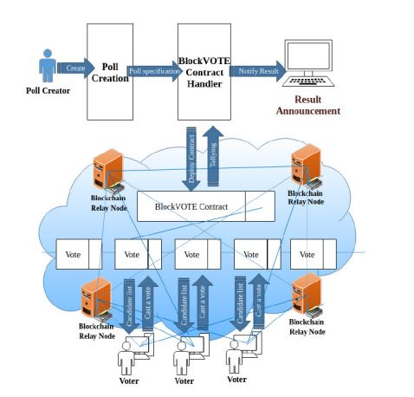

Figure Architecture of E-Voting

Our main motivation behind this project is to create a secure voting environment and show that a reliable e-voting scheme is possible using blockchain. Because when electronic voting is available to anyone with a computer or mobile phone, every single administrative decision can be made by people and members; or at least people's opinions will be more public and accessible to politicians and managers. This will eventually lead humanity to true direct democracy. This is important to us because elections can be easily corrupted or rigged, especially in small towns and even larger cities in corrupt countries. Moreover, large-scale traditional elections are very expensive in the long run, especially when there are hundreds of geographically distributed polling stations and millions of voters. Voter turnout at polling stations is also relatively low, as the person may not be staying at the address whose name is on the list, or maybe on vacation or other work. Electronic voting will be able to solve these problems if implemented carefully. The concept of electronic voting is significantly older than blockchain. So all known examples to date have used the means of centralized computing and storage models. By implementing blockchain, we can increase the security level of our system due to its way of storing data in a decentralized network. This project also has a facial recognition system to verify whether the user is valid or not. Some systems were found to have an OTP system to authenticate the user. But in this authentication model, the disadvantage is that if x person's phone is not with him, even though his phone is with his friend, his friend can vote twice because of the OTP system, one with the original chance and one because of his friend's login, and then x can't vote. So here comes the face recognition technique where the user has to verify his face before voting to maintain transparency.

Estonia is a very good example as the Estonian government is one of the first to implement a fully online and comprehensive e-voting solution. The concept of electronic voting began to be discussed in the country in 2001 and was officially launched by the national authorities in the summer of 2003. Their system is still in use, with many improvements and modifications to the original scheme. As mentioned, it is currently very robust and reliable. They use smart digital ID cards and personal card readers (distributed by the government) for personal authentication. There is a dedicated web portal and an equivalent desktop application for citizens to participate in the elections by nominating candidates and casting their votes. So that anyone with a computer, an internet connection, and also an ID card can easily vote remotely.

Switzerland is another of the few countries participating in the electronic voting trend. In Switzerland, known for its widespread democracy, every citizen who reaches the age of 18 can actively or passively participate in elections, which can be held on many different topics for many different decisions. They also started official work on a voting system called remote voting. Case in point – March 2018 general elections in Sierra Leone – Swiss startup Agora conducted a count in two districts. After the vote, a team of accredited observers from various locations manually entered approximately 400,000 ballots into Agora's blockchain system. This system was a partial deployment of the blockchain and the voting was verified by the blockchain and not powered by the blockchain.

### 3.6.2 Solidity

Solidity is an object-oriented, high-level programming language used to create smart contracts that automate transactions on the blockchain. After being proposed in 2014, the language was developed by contributors to the Ethereum project. The language is primarily used to create smart contracts on the Ethereum blockchain and create smart contracts on other blockchains.

Solidity is similar to one of the most common programming languages, JavaScript. It can be considered as a dialect of JavaScript. This means that if you understand JavaScript, it can be easy to pick up Solidity. Solidity also shares similar characteristics to the programming languages C++ and Python.

As a high-level language, Solidity does away with the need to type code in ones and zeros. It makes it much easier for humans to write programs in ways they find easier to understand, using a combination of letters and numbers.

Solidity is statically typed, with support for inheritance, libraries, and complex user-defined types. As Solidity is statically typed, the user much specify each variable. Data types allow the compiler to check for the correct use of variables. Solidity data types are usually categorized as either value types or reference types.

The main difference between value types and reference types can be found in how they are assigned to a variable and stored in the EVM (Ethereum Virtual Machine). While changing the value in one variable of a value type does not affect the value in another variable, anybody referring to changed values in reference type variables may get updated values.

* **How Does Solidity Work?**

The beauty of the Ethereum ecosystem is that so many different cryptocurrencies and decentralized applications can use it. Smart contracts make it possible for unique technologies to be made on Ethereum for all kinds of businesses and organizations.

Every year, the world spends billions of dollars on blockchain solutions. Many of these solutions are created using Solidity. Smart contracts built using Solidity can be thought of as a way to automate business and non-business processes between different people. This ensures that people making transactions on the blockchain.

### 3.6.3 Smart Contract

A smart contract, like any contract, establishes the terms of an agreement. But unlike a traditional contract, a smart contract’s terms are executed as code running on a blockchain like Ethereum. Smart contracts allow developers to build apps that take advantage of blockchain security, reliability, and accessibility while offering sophisticated peer-to-peer functionality everything from loans and insurance to logistics and gaming.

* **How do smart contracts work?**

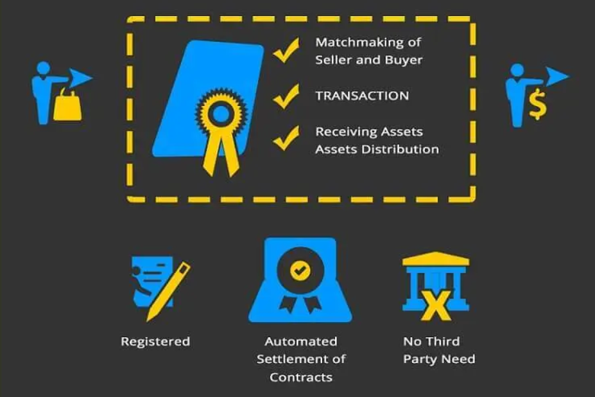

Figure Smart Contract Working

Smart contracts are written in a variety of programming languages (including Solidity, Web Assembly, and Michelson). On the Ethereum network, each smart contract’s code is stored on the blockchain, allowing any interested party to inspect the contract’s code and current state to verify its functionality.

Each computer on the network (or “node”) stores a copy of all existing smart contracts and their current state alongside the blockchain and transaction data.

When a smart contract receives funds from a user, its code is executed by all nodes in the network in order to reach a consensus about the outcome and resulting flow of value. This is what allows smart contracts to securely run without any central authority, even when users are making complex financial transactions with unknown entities.

To execute a smart contract on the Ethereum network, you will generally have to pay a fee called “gas” (so named because these fees keep the blockchain running).

### 3.6.4 Ethereum

Ethereum is a technology for building apps and organizations, holding assets, transacting and communicating without being controlled by a central authority. There is no need to hand over all your personal details to use Ethereum - you keep control of your own data and what is being shared. Ethereum has its own cryptocurrency, Ether, which is used to pay for certain activities on the Ethereum network. Here are some benegits of ethereum.

* Large, existing network. The benefits of Ethereum are a tried-and-true network that has been tested through years of operation and billions of value trading hands. It has a large and committed global community and the largest ecosystem in blockchain and cryptocurrency.
* Wide range of functions. Besides being used as a digital currency, Ethereum can also process other financial transactions, execute smart contracts and store data for third-party applications.
* Constant innovation. A large community of Ethereum developers is constantly looking for new ways to improve the network and develop new applications. “Because of Ethereum’s popularity, it tends to be the preferred blockchain network for new and exciting (and sometimes risky) decentralized applications,” Avital says.
* Avoids intermediaries. Ethereum’s decentralized network promises to let users leave behind third-party intermediaries, like lawyers who write and interpret contracts, banks that are intermediaries in financial transactions or third-party web hosting services.

Ethereum Disadvantages :

* Rising transaction costs. Ethereum’s growing popularity has led to higher transaction costs. Ethereum transaction fees, also known as “gas,” can fluctuate and be quite costly. That’s great if you’re earning money as a miner but less so if you’re trying to use the network. Unlike Bitcoin, where the network rewards transaction verifiers, Ethereum requires those participating in the transaction to cover the fee.
* Potential for crypto inflation. While Ethereum has an annual limit of releasing 18 million Ether per year, there’s no lifetime limit on the potential number of coins. This could mean that as an investment, Ethereum might function more like dollars and may not appreciate as much as Bitcoin, which has a strict lifetime limit on the number of coins.
* Steep learning curve for developers. Ethereum can be difficult for developers to pick up as they migrate from centralized processing to decentralized networks.

**3.6.5 Metamask**

MetaMask is a cryptocurrency wallet that is available as a browser extension to help you store tokens, interact with decentralized applications, and trade Ethereum. By connecting users with MyEtherWallet, MetaMask eliminates the need to enter private keys at the execution of each transaction while creating, storing, or trading tokens.

Users can store and manage their Bitcoin, Ether, and other cryptocurrencies using a blockchain wallet, which is available as a digital or online wallet. A blockchain wallet enables cryptocurrency transfers, prevents theft of crypto assets, and allows users to convert them back into their local currencies if needed. Its community is strong, with over a million downloads, and it has many resources contributing to the project.

The MetaMask browser extension is a browser extension that can act as your Ethereum wallet. Unlike traditional wallets, MetaMask requires no additional plug-ins, so you’re free to use it in any browser.

Once installed, you can view your Ethereum address and send or receive coins to any Ethereum address in turn. MetaMask allows you to stake coins on gambling sites and trade on DEXs, as well as participate in projects like PoolTogether and Compound.

### 3.6.6 Truffle

Truffle is the development environment, asset pipeline, and testing framework of the Truffle Suite ecosystem. Truffle is a hugely popular development framework for Ethereum dApp development, and there is a large community behind the tool. Furthermore, Truffle is using the EVM as a basis, and one of its purposes is to make the development of smart contracts more straightforward and more accessible.

### 3.6.7 Ganache

Ganache is a tool that allows us to spin up our own local Ethereum blockchain. The blockchain can be utilized throughout all parts of the development process, making this tool highly useful. As we set up our local blockchain, Ganache allows us to deploy, develop and test all our dApps in a safe and deterministic environment.

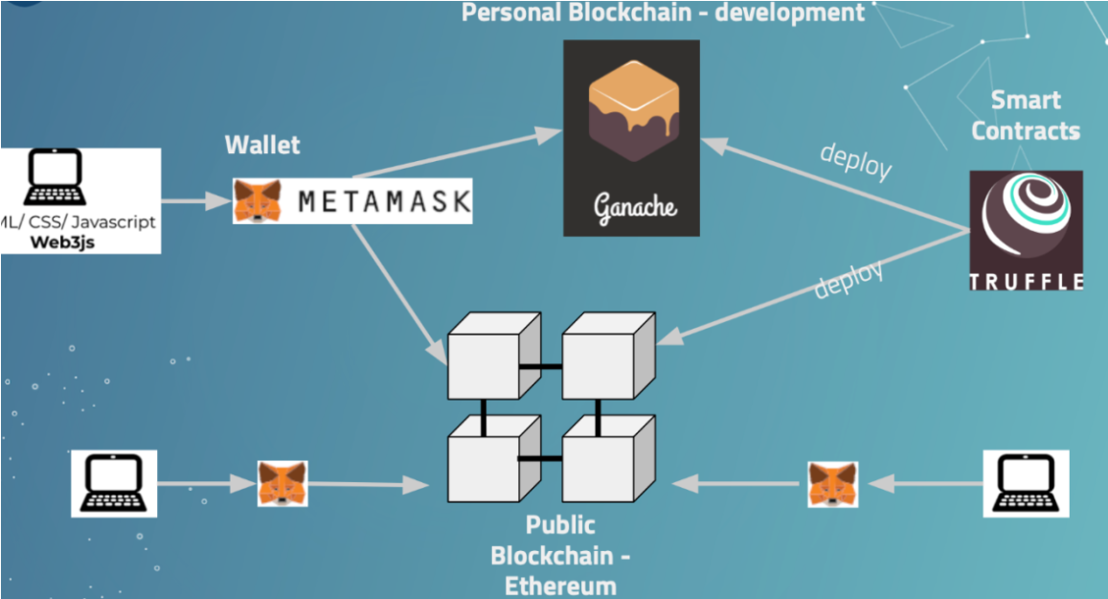

Figure Blockchain Transaction Flow

## 3.7 Face Recognition

User Identification is done here with the help of face recognition technique. In order to cast vote to any candidate, user need to first authenticate by using face recognition. Face Recognition will ensure reliability that the person who is voting is a validate one and no other person is voting inspite of him/her.

Recognize and manipulate faces from Python or from the command line with the world’s simplest face recognition library. Built using dlib’s state-of-the-art face recognition built with deep learning. The model has an accuracy of 99.38% on the Labeled Faces in the Wild benchmark. This also provides a simple face_recognition command line tool that lets you do face recognition on a folder of images from the command line.

### 3.7.1 Features

* **Find face**

|  |  |
| --- | --- |
|  |  |

Figure Find Face

* **Find and manipulate facial features**

Get the locations and outlines of each person’s eyes, nose, mouth and chin.

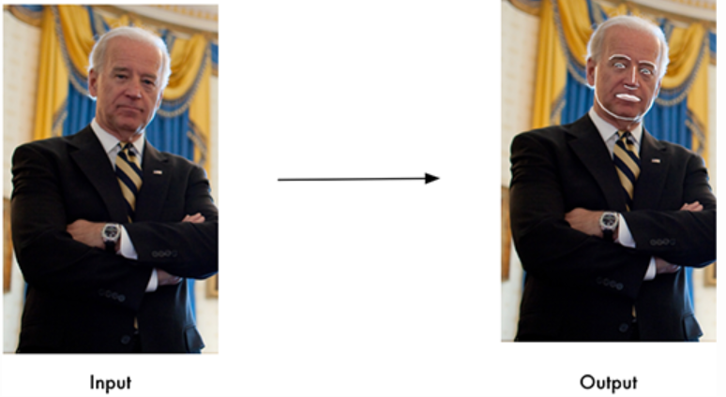

Figure Extract Facial Feature

* **Identify faces in pictures**

Recognize who appears in each photo.

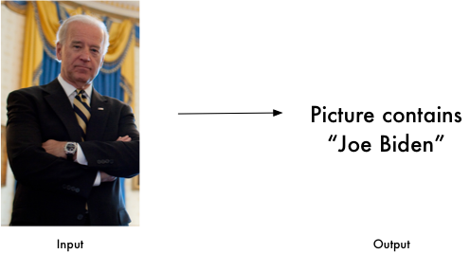

Figure Identify Faces

### 3.7.2 Command-Line Interface

When you install face_recognition, you get a simple command-line program Called face_recognition that you can use to recognize faces in a photograph or folder full for photographs. First, you need to provide a folder with one picture of each person you

already know. There should be one image file for each person with the

files named according to who is in the picture. Next, you need a second folder with the files you want to identify

Then in you simply run the command face_recognition, passing in the folder of known people and the folder (or single image) with unknown people and it tells you who is in each image.

There’s one line in the output for each face. The data is comma-separated with the filename and the name of the person found. An unknown_person is a face in the image that didn’t match anyone in your folder of known people.

## 3.8 Timeline Chart

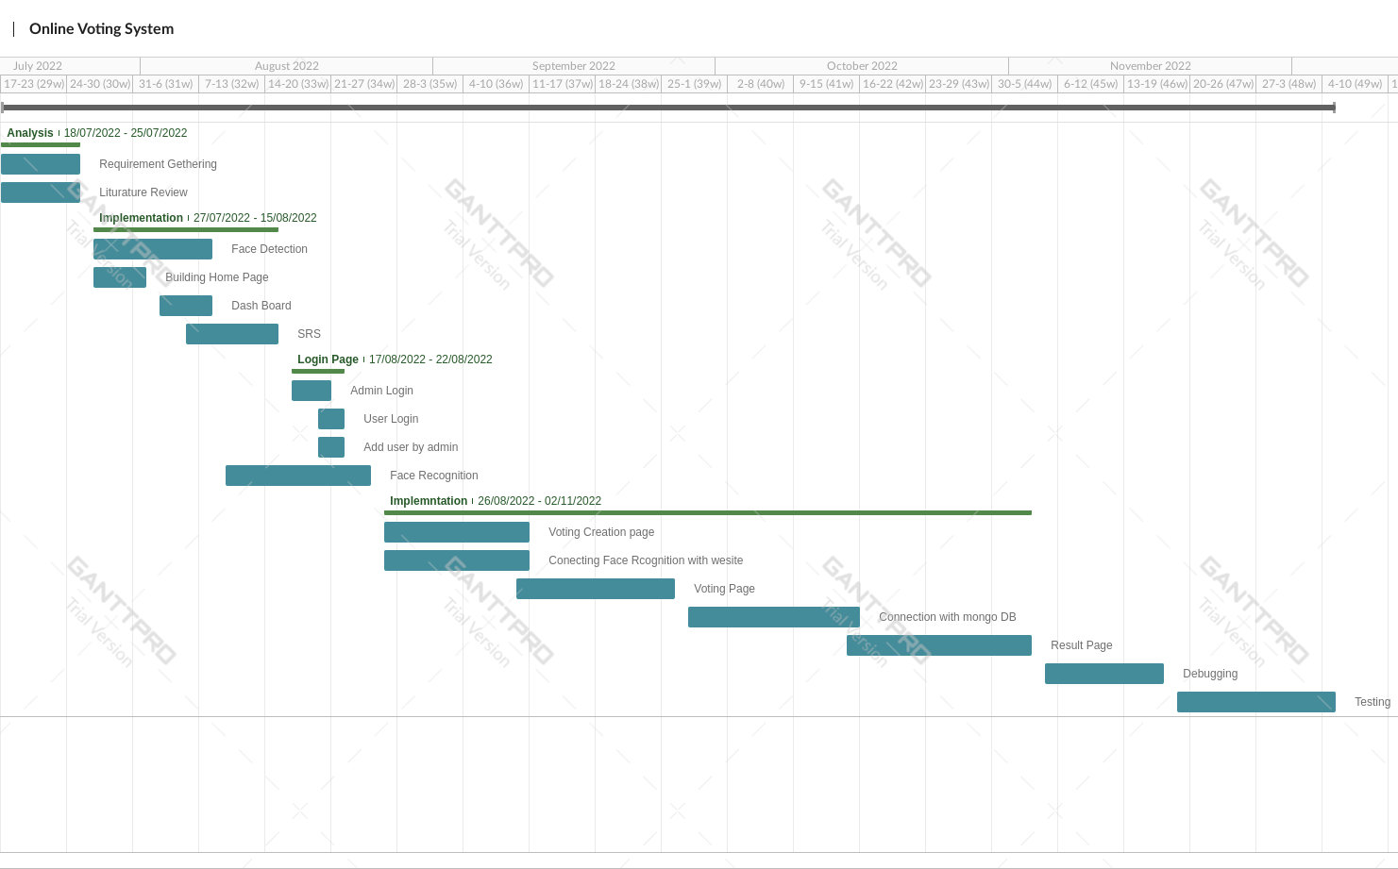

Figure Project Timeline Chart

# **Chapter 4: Implementation and Testing**

## 4.1 Software and Tools

### 4.1.1 Hardware Requirements

* Hardware that supports web app (E.g., Mobile, Computer)

Hardware must be there until it is hosted to cloud servers and ready to pitch. After that anyone can use it through any smartphones or pc that has web browser inside.

### 4.1.2 Software Requirements

* Front-End: React-js
* React is a JavaScript library for building user interfaces.
* React is used to build single-page applications.
* React allows us to create reusable UI components.
* Back-End: Solidity
  + Solidity is an object-oriented, high-level language for implementing smart contracts. Smart contracts are programs which govern the behaviour of accounts within the Ethereum state.
  + Solidity is a Curly bracket language designed to target the Ethereum Virtual Machine (EVM). It is influenced by C++, Python and JavaScript. You can find more details about which languages Solidity has been inspired by in the language influences section.
  + Solidity is statically typed, supports inheritance, libraries and complex user-defined types among other features.
  + With Solidity you can create contracts for uses such as voting, crowdfunding, blind auctions, and multi-signature wallets.
  + When deploying contracts, you should use the latest released version of Solidity. Apart from exceptional cases, only the latest version receives security fixes. Furthermore, breaking changes as well as new features are introduced regularly. We currently use a 0.y.z version number to indicate this fast pace of change
* Others: Domain name, Hosting, sever and cloud storage

This web application needs to be computer under solidity language as it is the Blockchain technology supported as well the latest front-end language React-js that should be pre-installed in hardware in complete working position.

### 4.1.3 Software requirements for our clients

* Windows 7 or higher OS
* Google chrome or any other safe browser

Client just need not to worry about anything just trust on over new innovation and head towards the transaction through any smartphone or pc that has web browser inside.

## 4.2 User Interface and Snapshots

### 4.2.1 Admin Login

Admin Login used for admin to Login in the System without email address and password admin or any other person can not login using this module as shown in Figure 19.

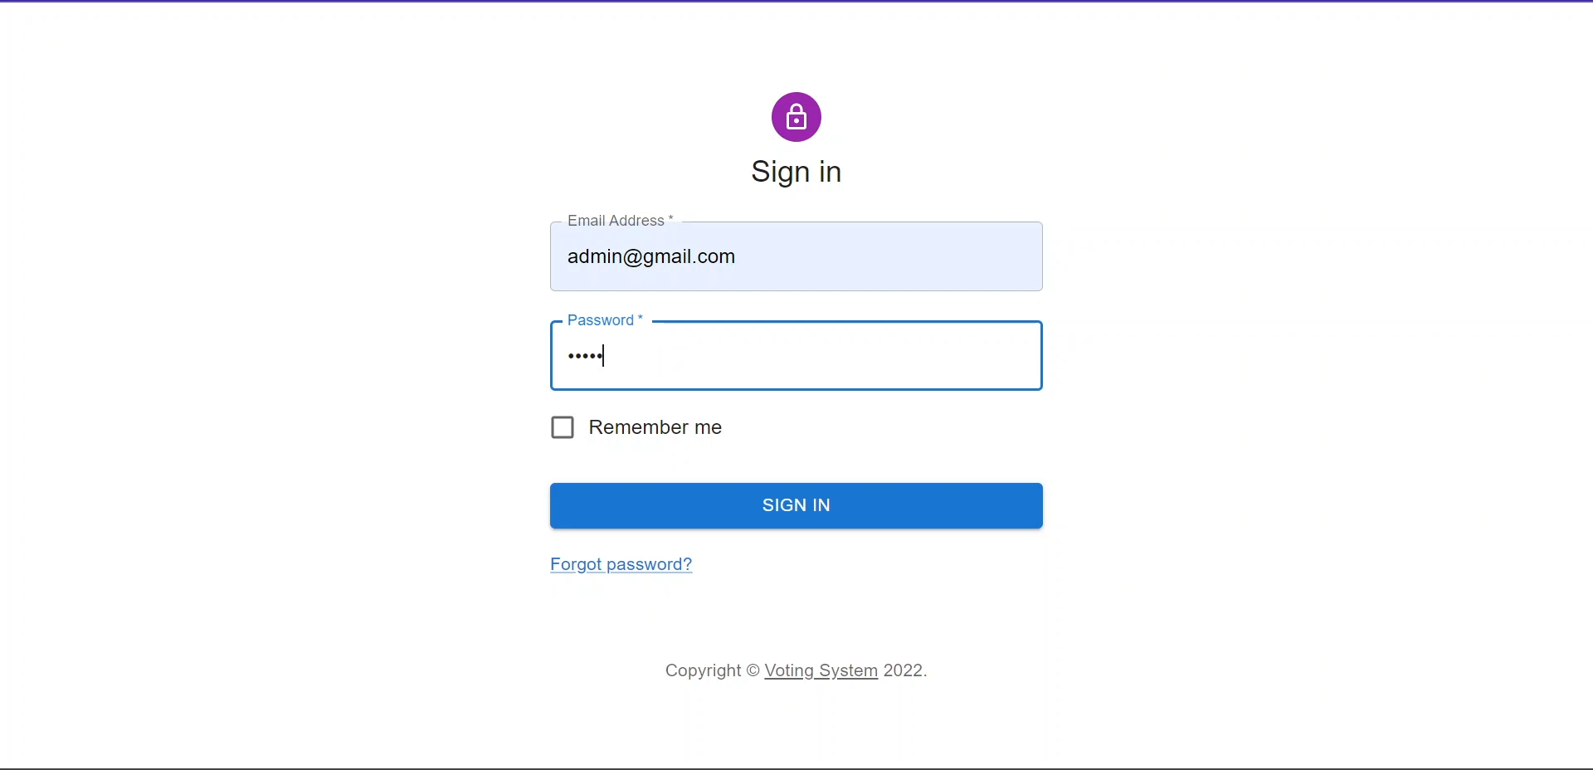

Figure Admin Login

### 4.2.2 Admin Dashboard

Here Figure 20 shows Admin Dashboard where admin get all the information like total number of users, candidates and elections available in the system and also navigate to other modules like user candidate, election changing phase or showing result.

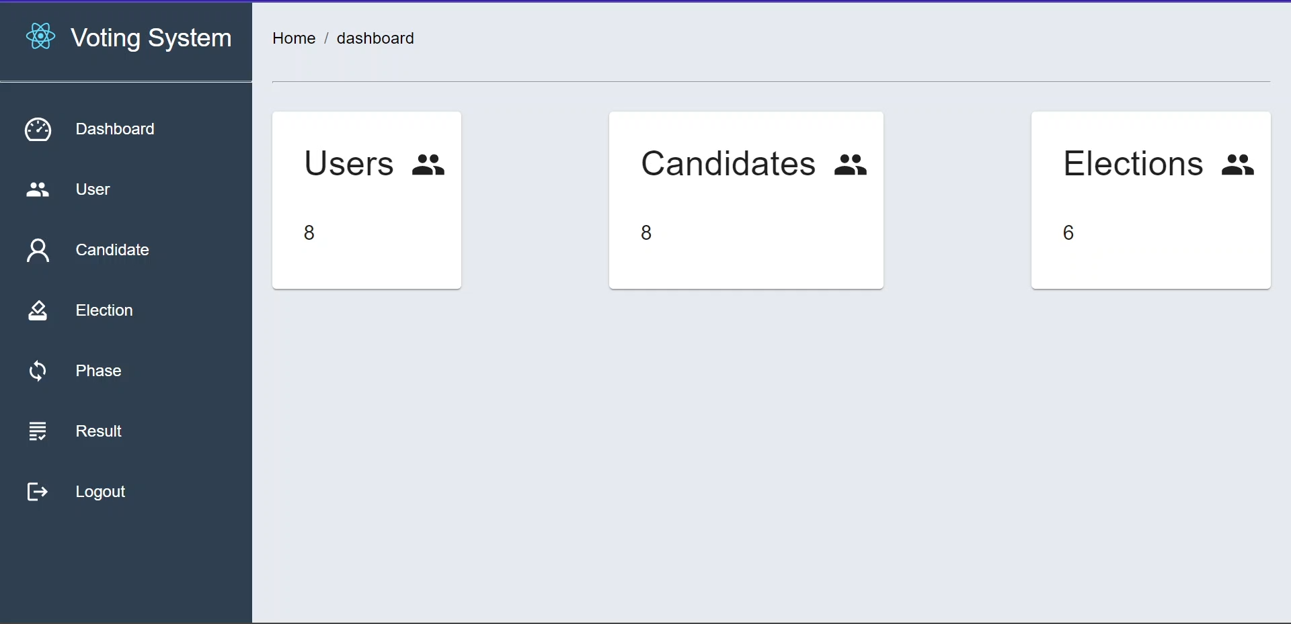

Figure Admin Dashboard

### 4.2.3 View Users

Admin can view details of the users as shown in Figure 21. he can perform operations like edit users or delete user and add the user in the voting system.

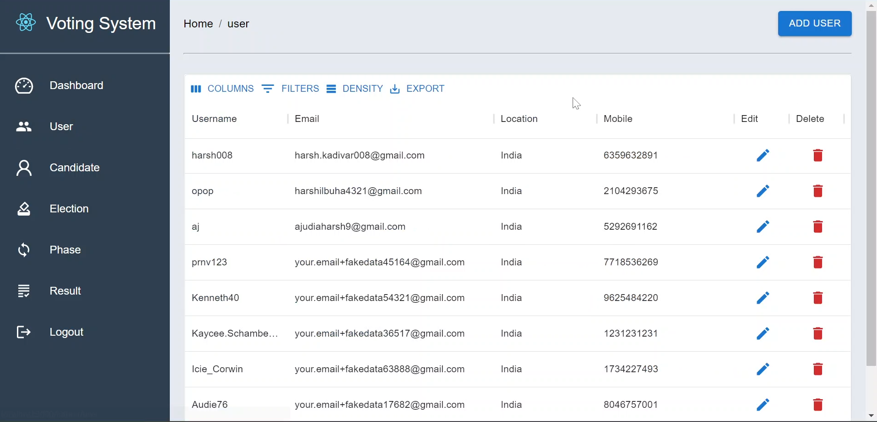

Figure View Users

### 4.2.4 Add User

Admin can add user in the system using this gui where admin have to fill details like username, first name and other details after click on add user user will get username and password in the e-mail which is entered in the given form.

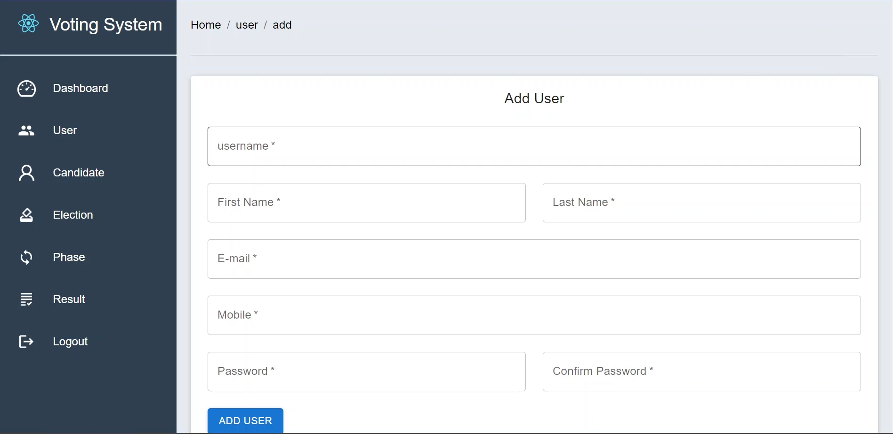

Figure Add User

### 4.2.5 Add Candidate

Admin can add candidate and in the voting phase user will vote for this candidates.

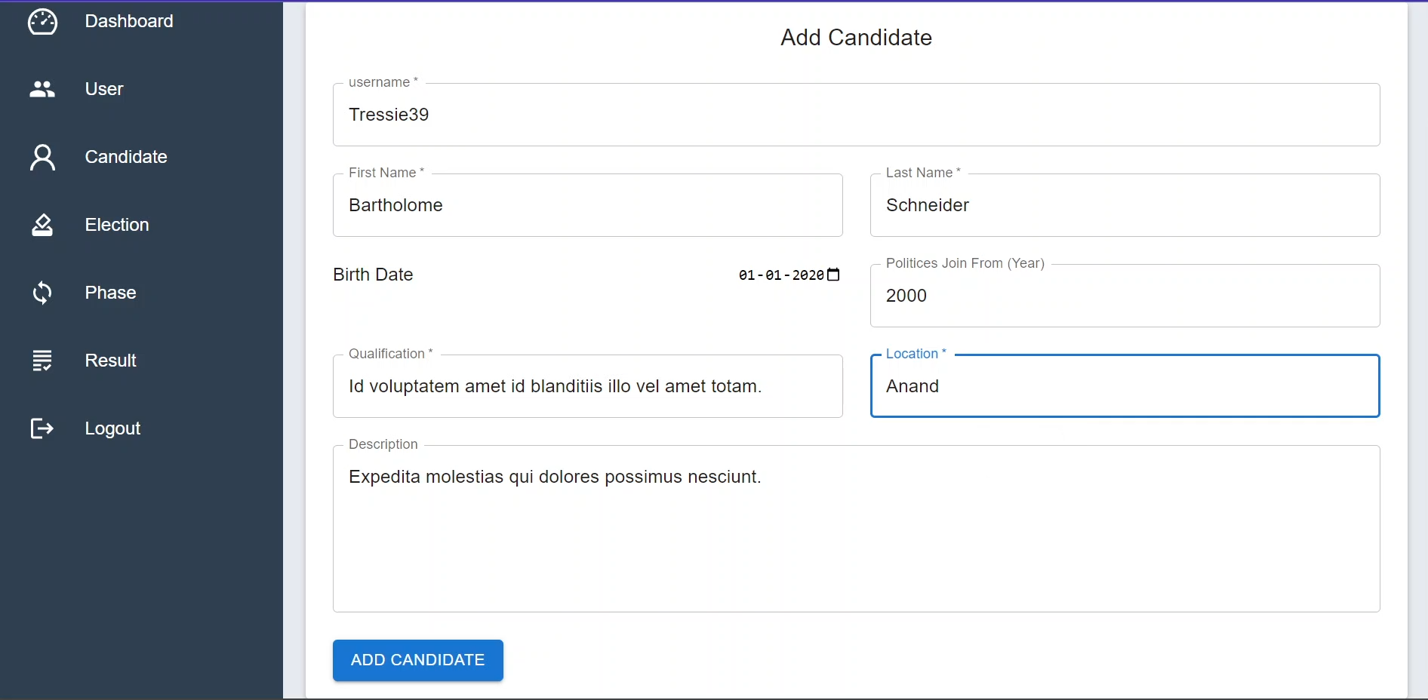

Figure Add Candidate

### 4.2.6 Add Election

Admin can add new election in the system with the unique election name and also add candidate from the available candidate with the dropdown menu of candidates.

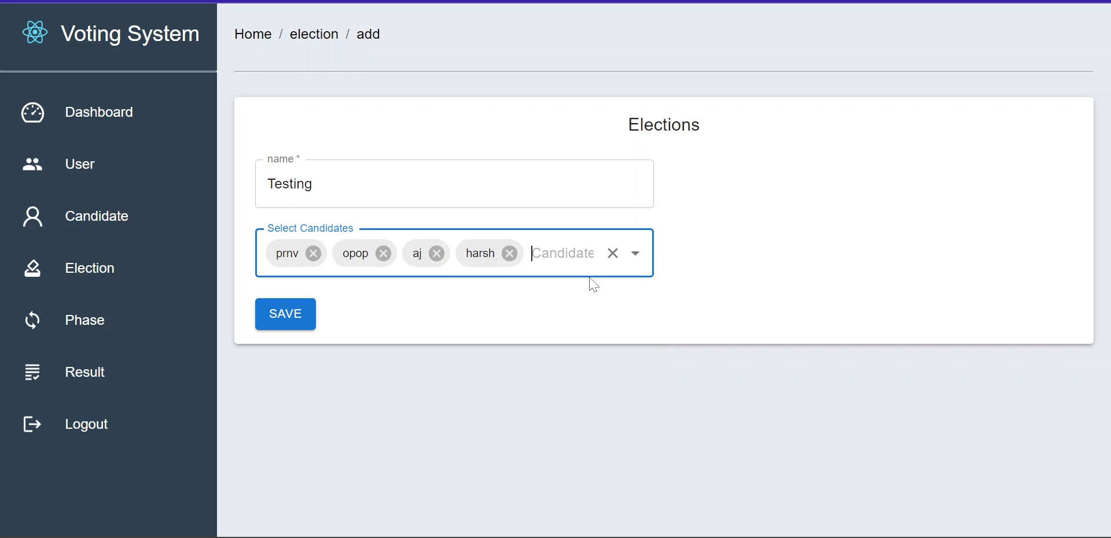

Figure Add Election

### 4.2.7 Edit Phase

From this Page Admin can change the phase of election.

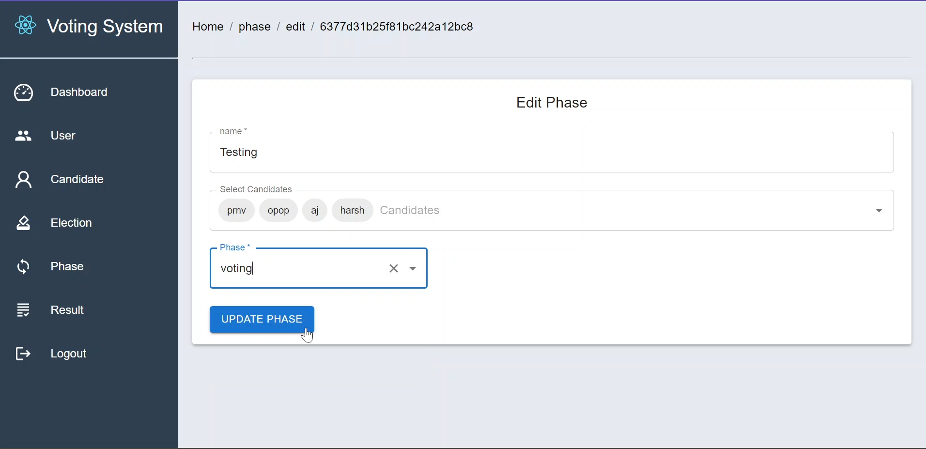

Figure Edit Phase

### 4.2.8 View Elections

Here User can select election in which election user want to vote.

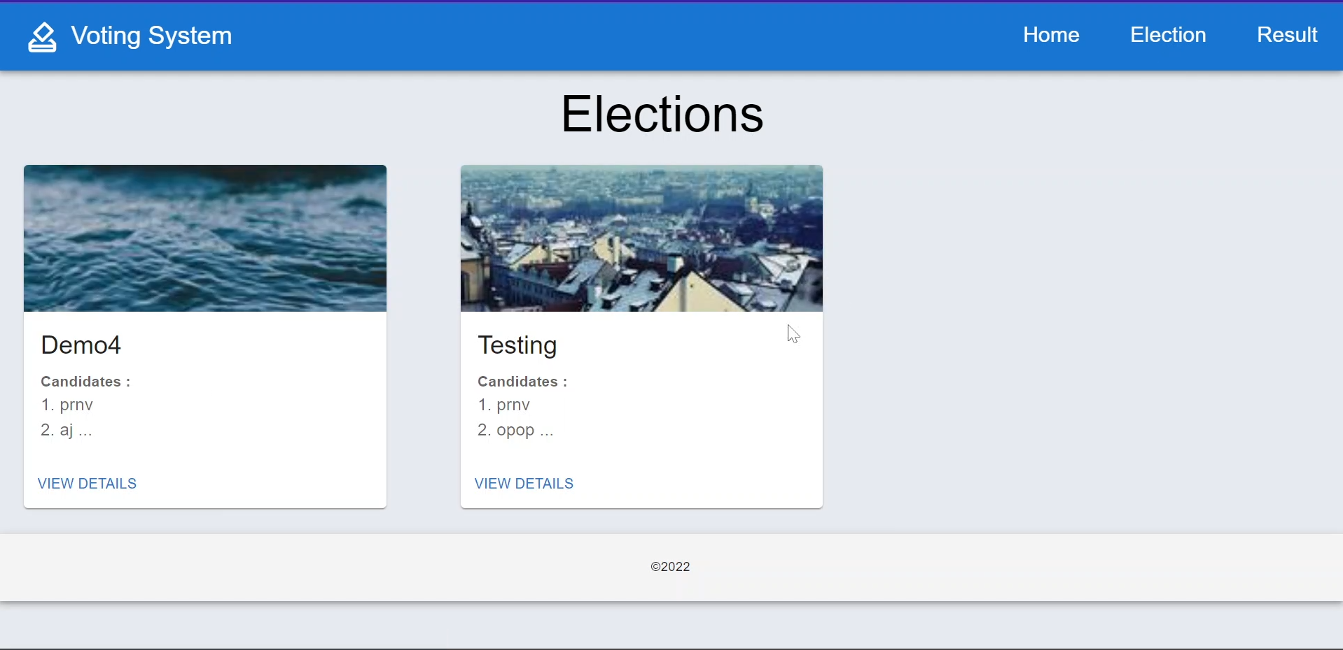

Figure Elections

### 4.2.9 Candidate of Election

Here user can select candidate for voting and click on vote the python script will be execute and camera will be open in 30 seconds.

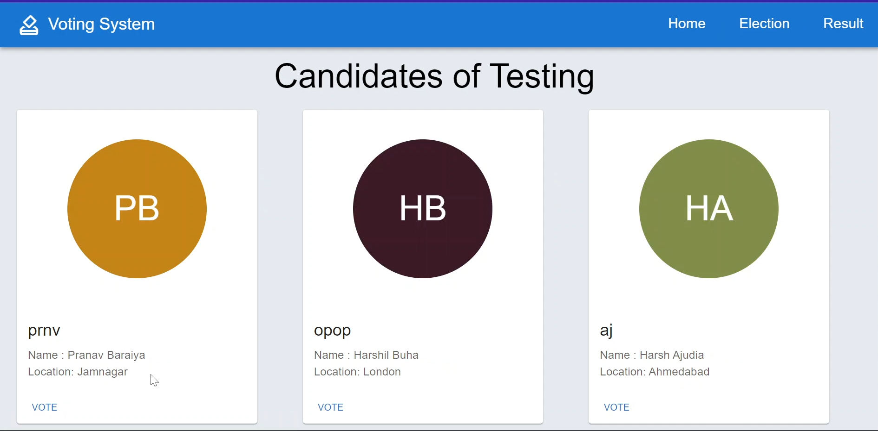

Figure Candidates of Elections

### 4.2.10 Login User

User will be recognize using python script and the username will be shown in the username box automaticaly After entering right password metamask will be open for transaction.

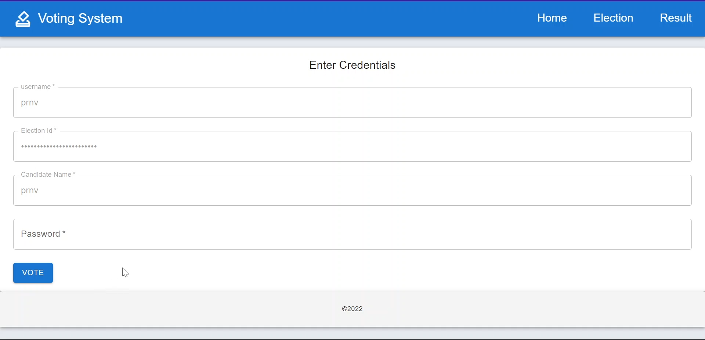

Figure User Login Page

### 4.2.11 Metamask Transaction Details

Here Ethereum will be transfer from user account to candidate account using metamask After confirming transaction user will get alert for successful transaction and also get email.

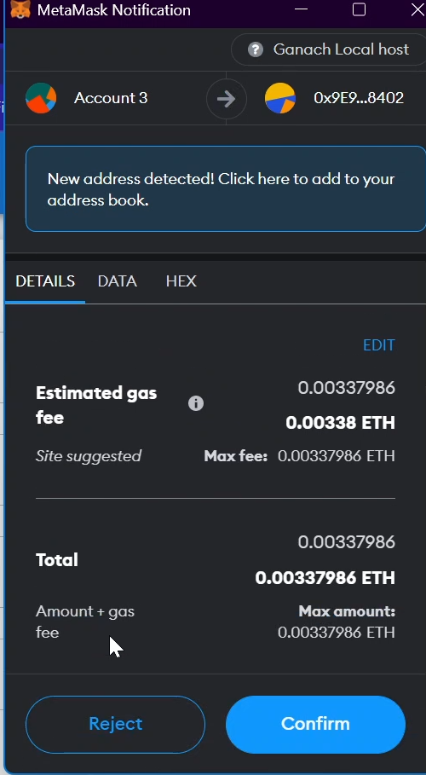

Figure Transcation Details

### 4.2.12 Result of Elections

Here user can view all the election which phase is result and view details of the elections.

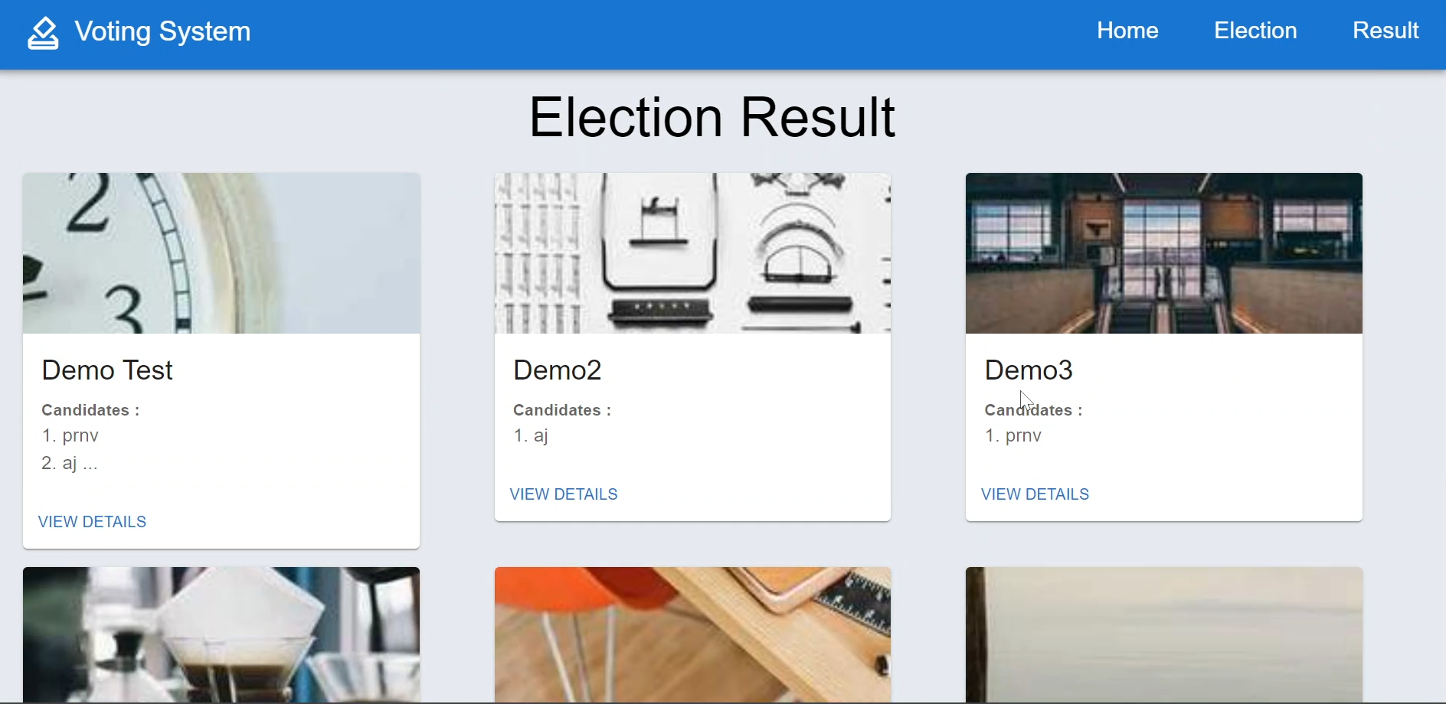

Figure Result of Elections

### 4.2.13 Result of Candidates

Here user can view total vote of the perticular candidate which election is choosen.

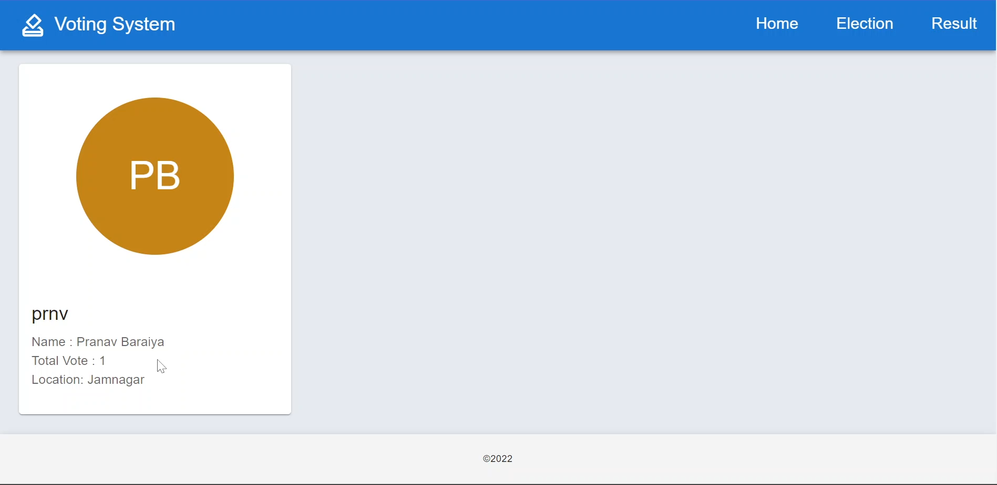

Figure Candidate Result

# **Chapter 5: Conclusion and Future work**

## 5.1 Conclusion

To conclude in nutshell, by using this project, the user doesn’t need to worry about any special tool to write in the open space. With optimum use of resources, we can write and convey correct message to other party.

In the current situation, online work is unavoidable. Mainly, online education is proving harder as teachers sometimes feel difficult to teach without writing. This is where our project comes into picture.

Once the project website is hosted on server, anyone (i.e., teachers) can access it and using the web-camera one can easily do their task using writing. (i.e., Math teacher may use it to show equations to the students in online education)

To sum it up, we can say that using python libraries and OpenCV, we have created a tool through which all people who were unable to convey the message properly due to lack writing in real time during online meetings can now do it efficiently.

## 5.2 Future work

As this system can be mainly used for college voting so its part of face recognition can be used as an attendance system where we just have to add the scanned student name into a file.

This system uses etherium coins for casting the votes so in future we can use Hyperledger(i.e. it dosen’t uses a crytocurruncies for transaction) for implementing blockchain so we can make this system free for people to cast votes.